**Jenkins Upstream and Downstream Pipelines**

**Upstream Pipeline:**

An upstream pipeline is a Jenkins pipeline job that triggers another pipeline job. It is the job that comes before the dependent job in the workflow. When the upstream pipeline is executed and completed successfully, it triggers the downstream pipeline(s).

**Use case:**

If you have a project with multiple stages like build, test, and deploy. The "build" pipeline could be an upstream pipeline that triggers the "test" pipeline when the code compilation is successful.

**Downstream Pipeline:**

A downstream pipeline is a Jenkins pipeline job that is triggered by another pipeline job. It depends on the successful execution of the upstream pipeline(s). The downstream pipeline will not be executed until the upstream pipeline(s) have successfully completed.

**Use case:**

From the above example, the "test" pipeline could be a downstream pipeline that waits for the "build" pipeline to complete successfully before it starts running the tests.

**Creating Job1 using Freestyle Project:**

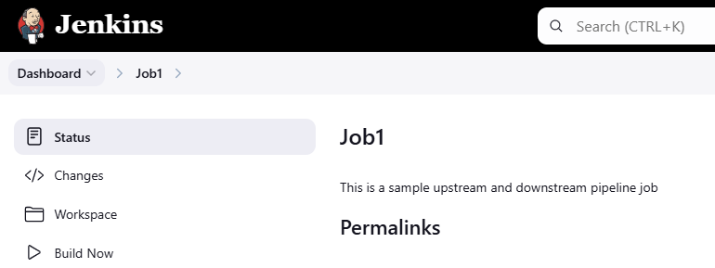

**Create Job2 and Job3 using Copy from option:**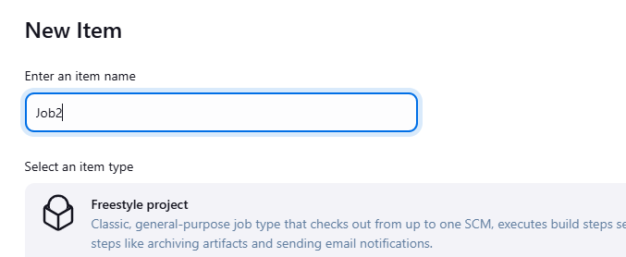

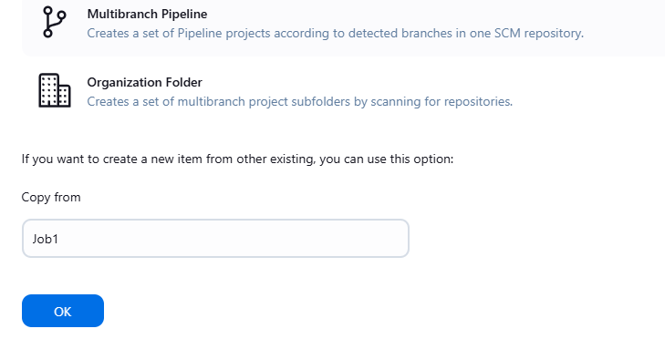

**Change the build step:**

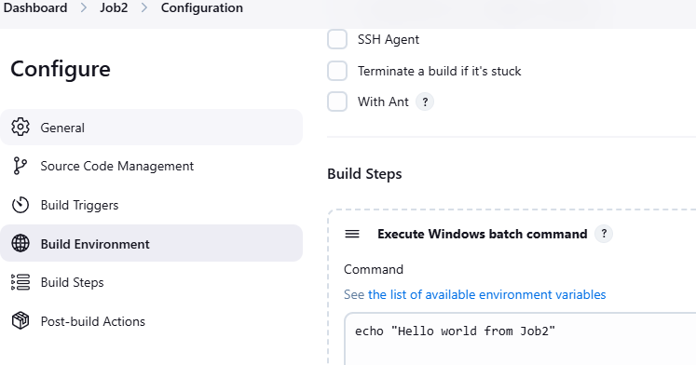

**Job3:**

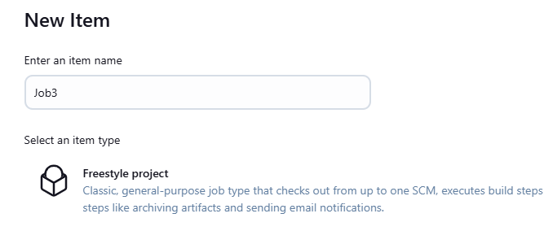

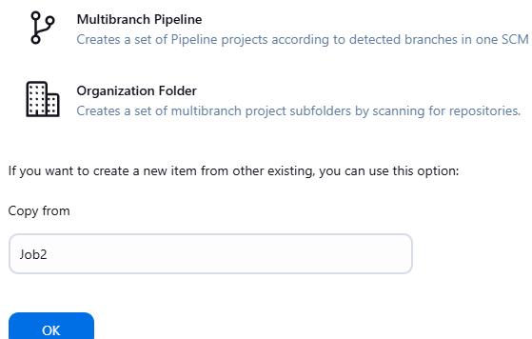

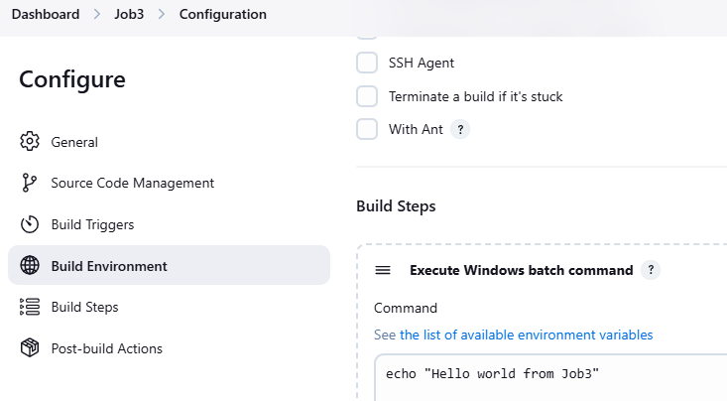

**Now, created 3 jobs.**

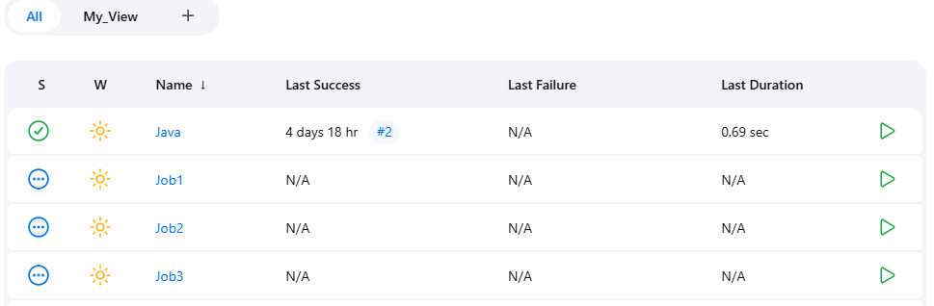

**Setting post build action for job2 and job1:**

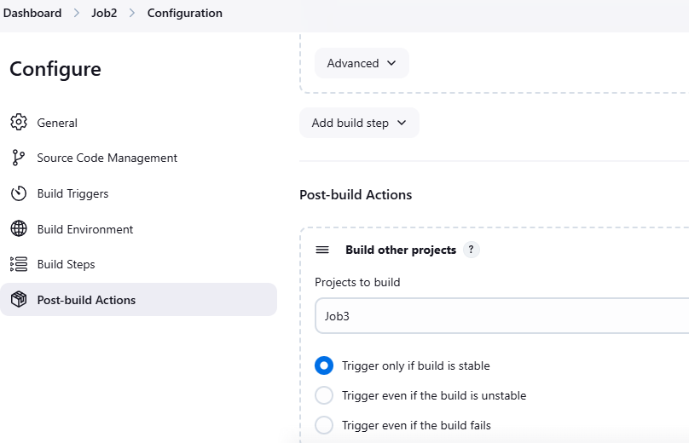

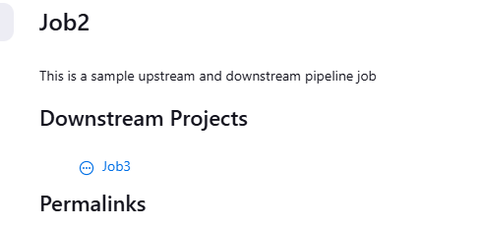

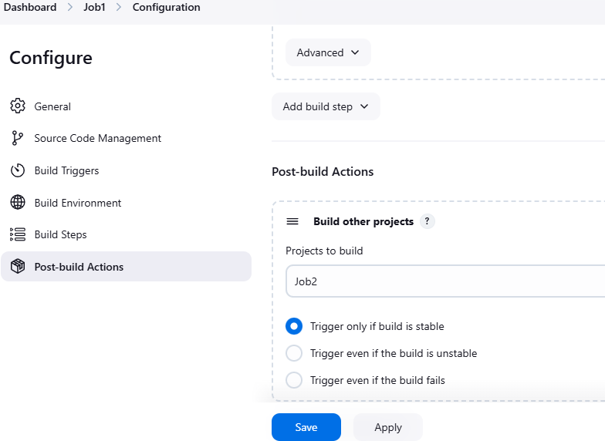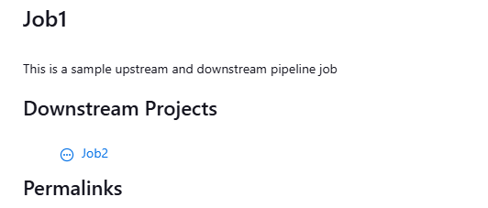

**Job2 has an upstream the Job1 and downstream the Job3:**

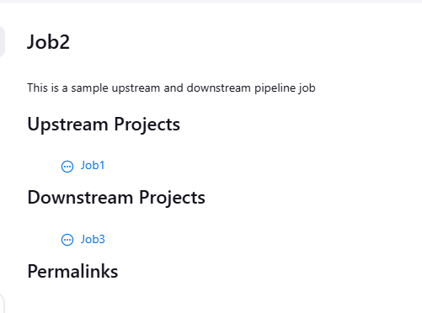

**Now build Job1, it will automatically triggers Job2 and Job3, when the Job1 finish its build:**

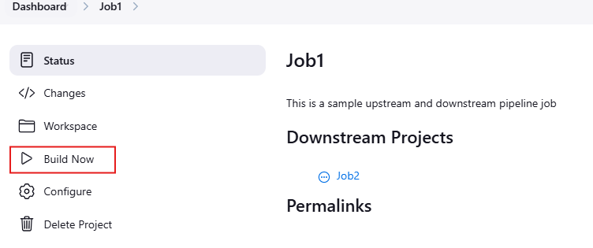

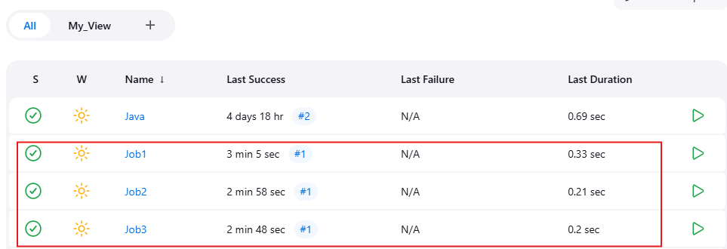

Job1:

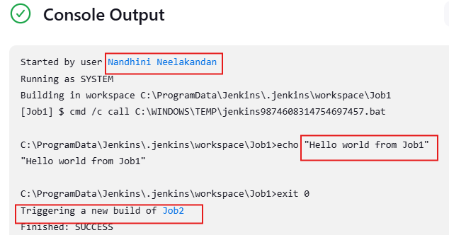

**Job2:**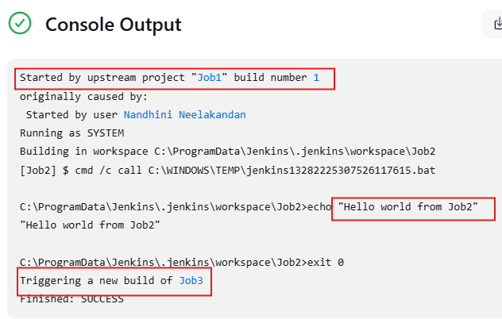

**Job3:**

